Product name: 16x2 character LCD module with ST7065 and ST7066
Part Number: KD1620-5/B
Key words： KD1620-5，16*2 LCD module， character LCD
Pictures:

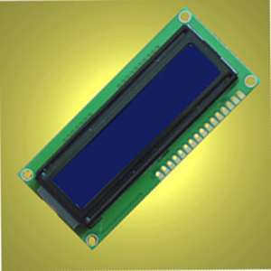

Short descriptions:
Compatible with 1620-5/B,1620-5,1620-5blue,
65*36.7*13.5mm
Driver:ST7065,ST7066
1. LCD name:16x2 character LCD module with ST7065 and ST7066
2. Part No.:1620-5/B
3. Other model Part No.:,1620-5,1620-5/B,1620-5B,1620-5 Blue
4. Compatible part No.:1620-5/B,1620-5,1620-5blue, 1620-5
5. Display type:STN
6. Resolution(pixels):5*8 dots in 16 characters*2 lines
7. Overall size:65.0*367.0*13.5mm
8. Viewing area:54.0*14.4.mm
9. Active Area: 49.7*9.4mm
10. character size:2.45*4.35mm
11. Dot pitch: 0.5*0.55mm
12. Display mode: negative
13. Background color:Blue
14. Backlight type and color:LED backlight/Blue
15. Display format:16 Characters * 2 Lines
16. Viewing direction: 6:00
17. Polarizers: transmissive
18. controller: ST7066U-OA,ST7065C
19. Operating temperature range: -20----70℃degrees
20. Storage Temperature range:-30----80℃ degrees
21. Lead time:
Sample(1---30 PCS): immediately
31---100PCS: 1 week
101---500 PCS:1--2 weeks
501---1000 PCS: 2--5 weeks
1001---5000 PCS:3--5 weeks
5000 PCS+： 5--7 weeks
22. Contact details:
Shenzhen Startek Electronic Technology Co.,Ltd
Mob:0086 1338 0338 626
Tel: 0086 755 6153 7663
Fax:0086 755 6153 7796
Email: lcd@lcdlcd.com
Msn: lcdstar@hotmail.com
Skype: lcdseller
QQ:3157 99773
Web: www.startek-lcd.com
Address:8/F,524 Zhoushi Road(the 4th Building at Huangmabu Village Mouth),Xixiang Town,Bao'an Disctrict,Shenzhen,518126

