Product name:16x1 character LCD module with ST7066
Part Number: KD1610A-4/B
Key words：KD1610 A-4/B，16*1 LCD module， character LCD
Pictures:

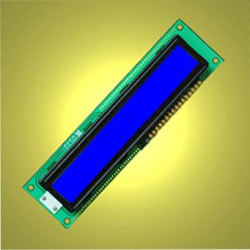

Short descriptions:
Compatible with
122*33*14mm
Driver: ST7066
1. LCD name:16x1 character LCD module with ST7066
2. Part No.:KD1610A-4
3. Other model Part No.:1610 A-4, 1610 A-4B,1610A-1Blue
4. Compatible part No.:
5. Display type:STN
6. Resolution(pixels):5*8 dots in 16 characters*1lines
7. Overall size: 122*33*14mm
8. Viewing area:99*14.mm
9. Active Area: 94.8*9.2mm
10. character size:14.5*9.22mm
11. Dot pitch: 0.98*1.16mm
12. Display mode: negative
13. Background color: blue
14. Backlight type and color:LED backlight/ blue
15. Display format:16 Characters * 1 Lines
16. Viewing direction: 6:00
17. Polarizers: transmissive
18. controller: ST7066U-OA
19. Operating temperature range: -20----70℃degrees
20. Storage Temperature range:-30----80℃ degrees
21. Lead time:
Sample(1---30 PCS): immediately
31---100PCS: 1 week
101---500 PCS:1--2 weeks
501---1000 PCS: 2--5 weeks
1001---5000 PCS:3--5 weeks
5000 PCS+： 5--7 weeks
22. Contact details:
Shenzhen Startek Electronic Technology Co.,Ltd Web: www.startek-lcd.com
Mob:0086 1338 0338 626 Tel: 0086 755 6153 7663 Fax:0086 755 6153 7796
Email: lcd@lcdlcd.com Msn: lcdstar@hotmail.com Skype: lcdseller QQ:3157 99773
Address:8/F,524 Zhoushi Road(the 4th Building at Huangmabu Village Mouth),Xixiang Town,Bao'an Disctrict,Shenzhen,518126

